SCHOOL OF COMPUTER SCIENCE AND ARTIFICIAL INTELLIGENCE |  |  |  |  | DEPARTMENT OF COMPUTER SCIENCE ENGINEERING
Program Name: M. Tech/MCA/MSC |  |  |  | Assignment Type: Lab |  |  | AcademicYear:2025-2026
Course Coordinator Name |  |  |  | Venkataramana Veeramsetty
Course Code |  |  |  | Course Title |  | AI Assisted Problem Solving Using Python
Year/Sem |  |  | II/I | Regulation |  | R25
Date and Day  of Assignment |  |  | Week5 - Tuesday | Time(s)
Duration |  |  | 2 Hours | Applicable to  Batches |  | M. Tech/MCA/MSC
AssignmentNumber:14.3(Presentassignmentnumber)/24(Totalnumberofassignments)
 | Q.No. | Question |  |  |  |  |  | ExpectedTime  to complete
 | 1 | Lab 14 – Web Frontend Development: AI-assisted HTML/CSS/JS with Python  Lab Objectives  - To understand how AI can generate HTML/CSS/JS templates.  - To practice integrating frontend and backend (Python) for small apps.  - To evaluate AI-generated code for readability, reusability, and responsiveness.  Learning Outcomes  After completing this lab, students will be able to:  - Generate HTML/CSS layouts using AI tools.  - Add JavaScript interactivity with AI suggestions.  - Integrate basic Python (Flask/Streamlit) backend to serve frontend.  - Evaluate AI-generated web code for responsiveness and usability.  - Debug and refine AI-generated frontend code.  Task Description #1 – AI-generated HTML Page  Task: Ask AI to generate a simple HTML homepage for a "Student Info Portal" with a header, navigation menu, and footer.  Expected Output:  - HTML code with <header>, <nav>, <footer>.  - Clean indentation, proper tags, and comments.  Prompt:  Create a simple HTML homepage for "Student Info Portal" using <header>, <nav>, <section>, and <footer>. Add a title in the header, a navigation menu, a welcome message in the section, and a small footer. Use clean indentation and only give the HTML code.  Code :  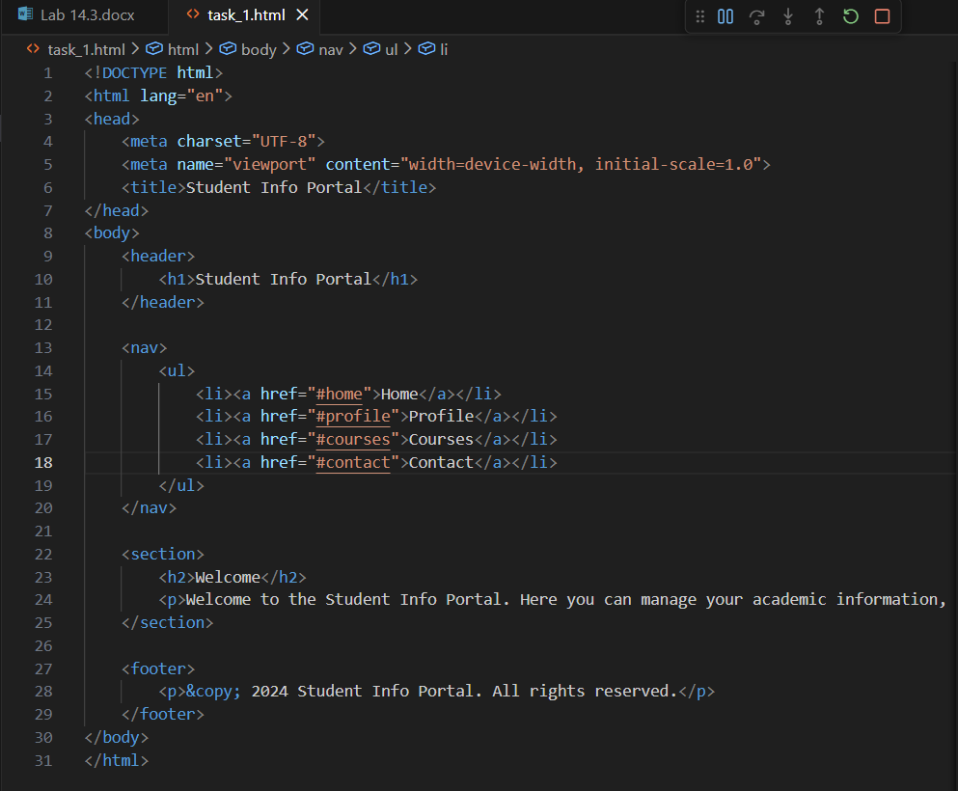  Output :  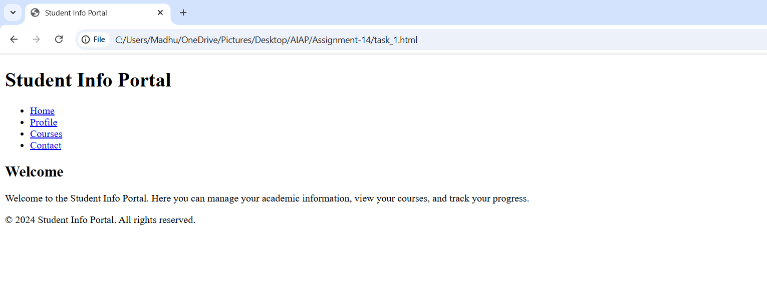  Task Description #2 – CSS Styling  Task:  Use AI to add CSS styling to Task #1 homepage for:  - Responsive navigation bar.  - Centered content section.  - Footer with light gray background.  Expected Output:  - HTML + CSS combined.  - AI explains how CSS classes apply.  Expected Output: AI refactors with with open() and try-except:  Prompt :  Add CSS to the Student Info Portal HTML page.  Make the nav bar responsive, center the content, and give the footer a light gray background.  Give me HTML + CSS in one file and explain the CSS classes.  Code :  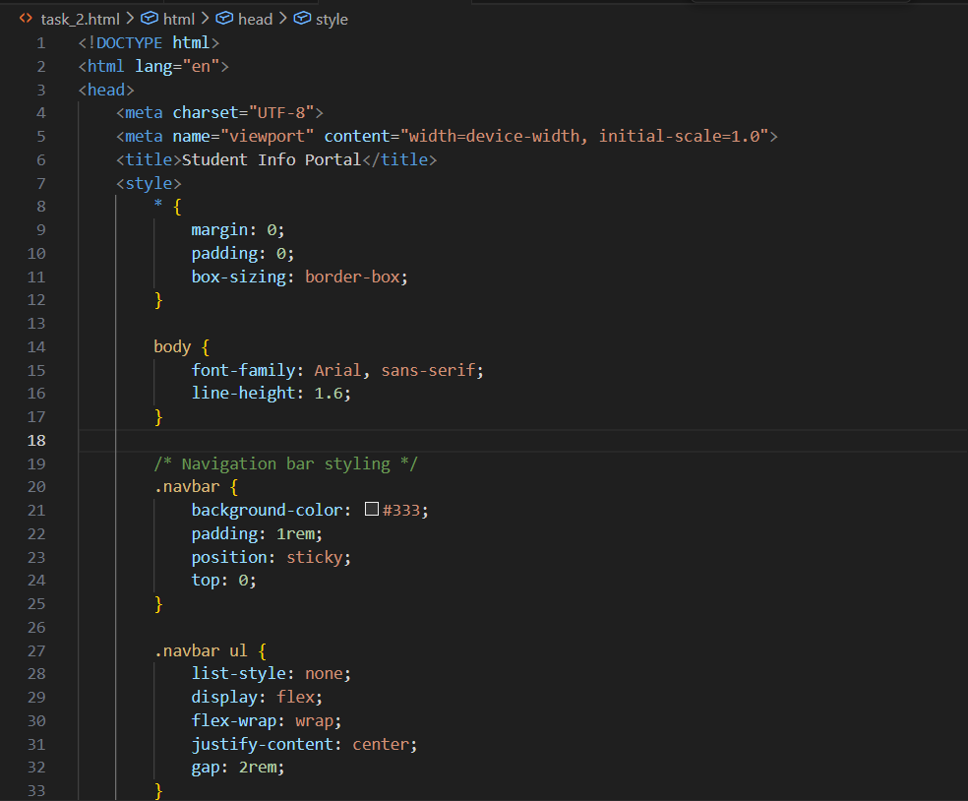  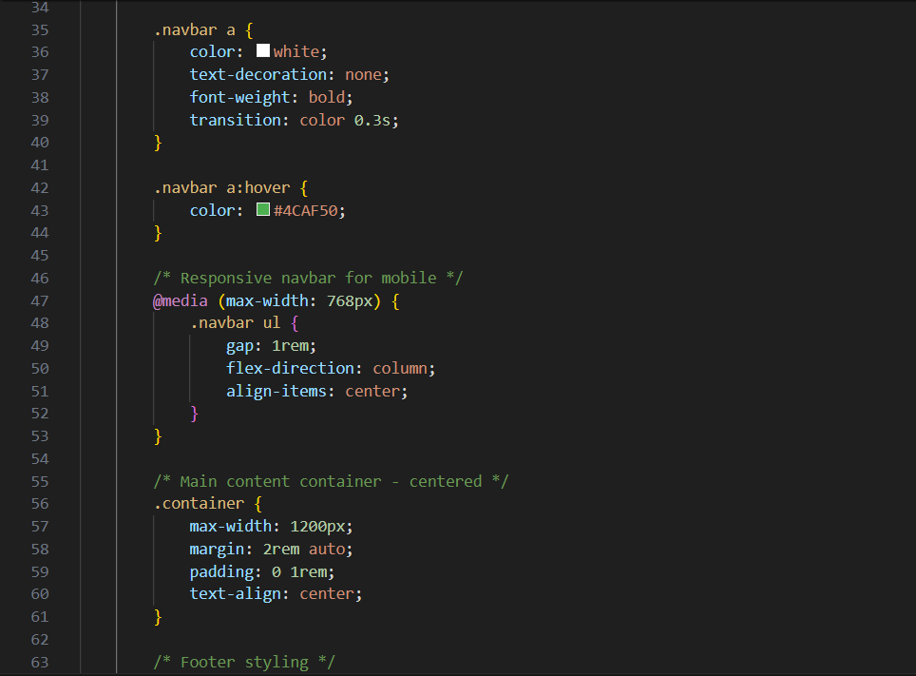  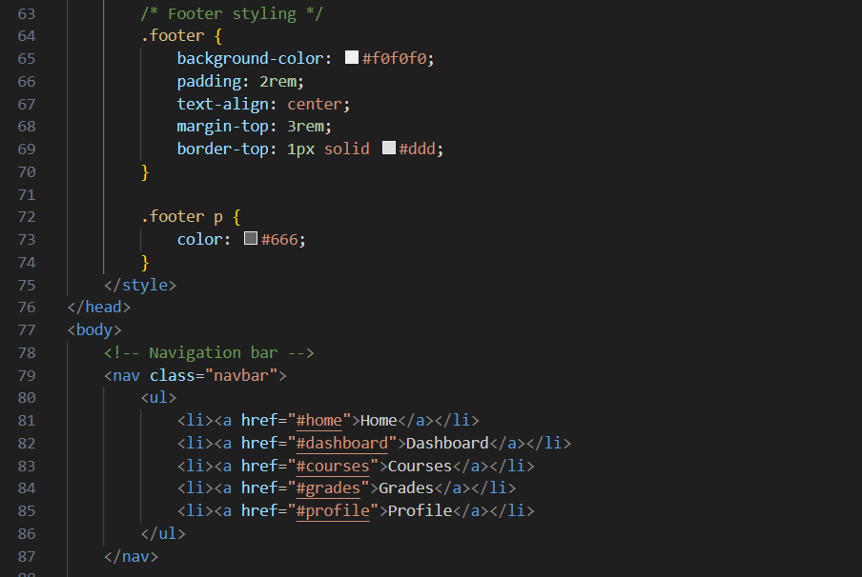  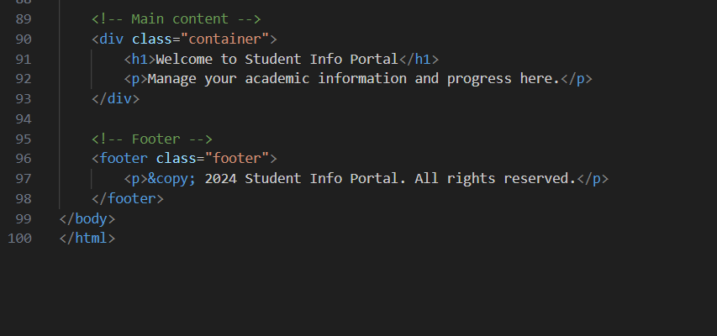  Output :  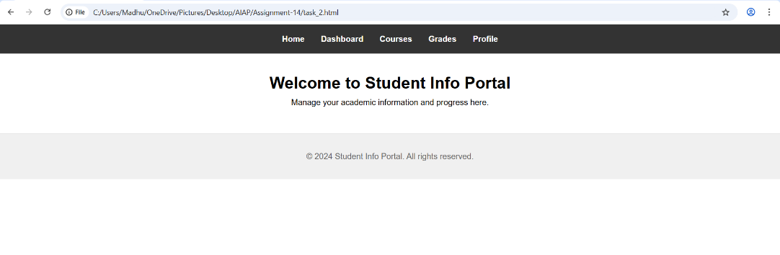  Task Description #3 – JavaScript Interactivity  Task: Prompt AI to generate a JS script that validates a simple login form (non-empty username/password).  Expected Output:  Working on submit JS validation.  Clear error messages if inputs are empty.  Prompt :  Add JavaScript validation to a login form.  Check that username and password are not empty when the user clicks submit.  If empty, show a clear error message.  Give me the full HTML + JS code.  Code :  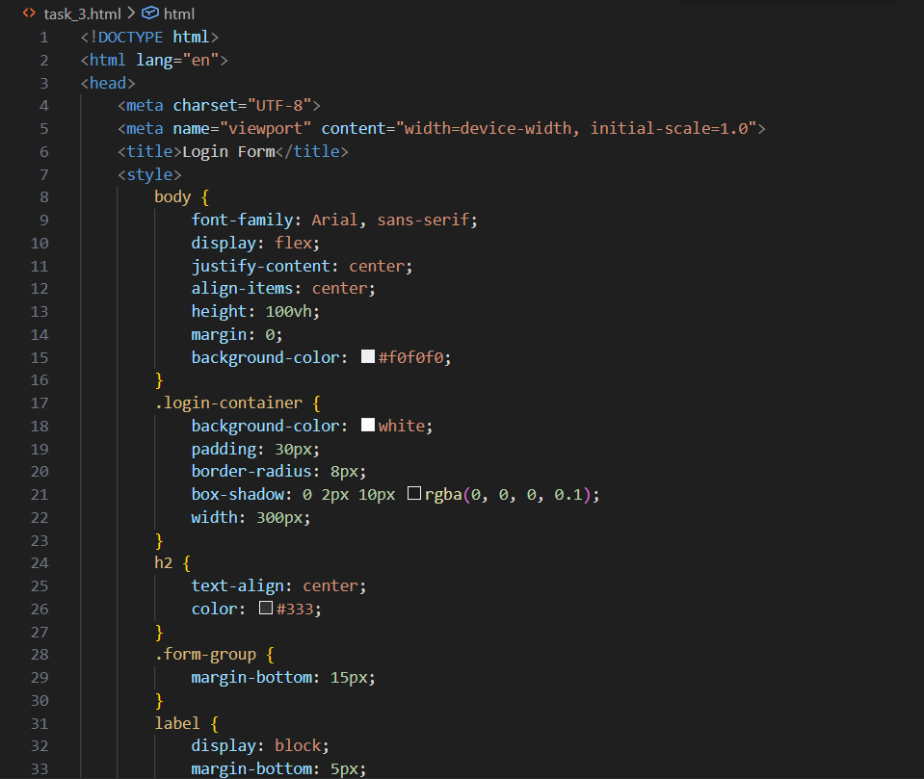  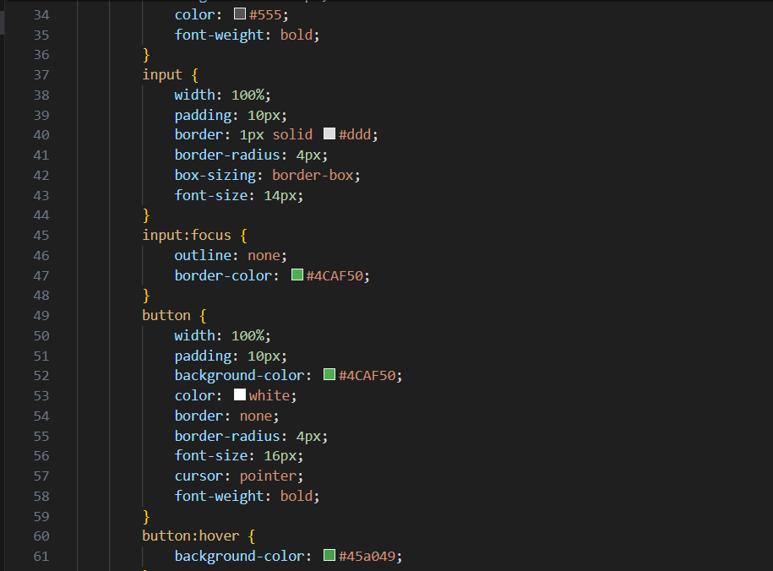  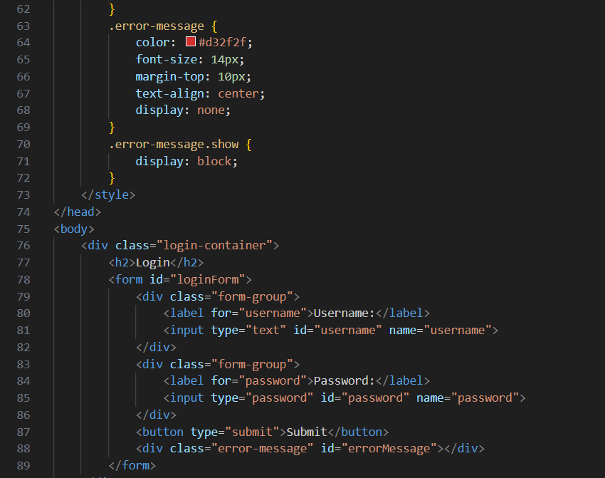  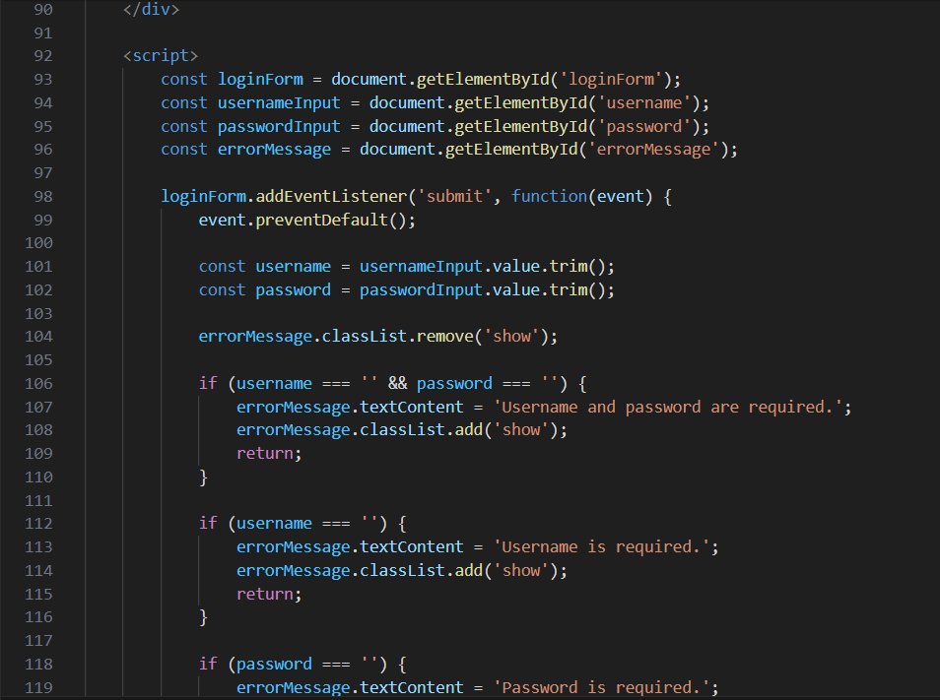  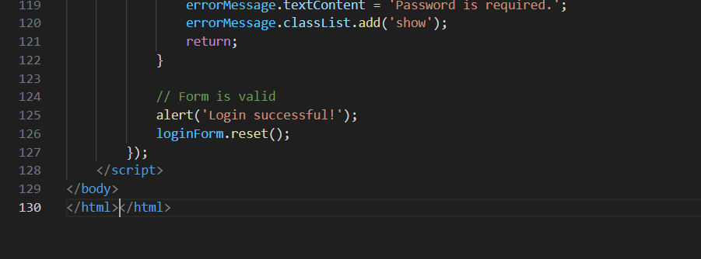  Output :  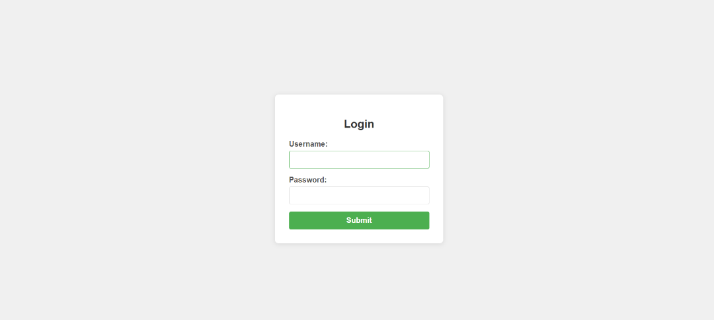  Task Description #4 – Python Backend Integration  Task: Ask AI to generate a Flask app that serves the HTML form (Task #3) and prints the username on successful login.  Code :  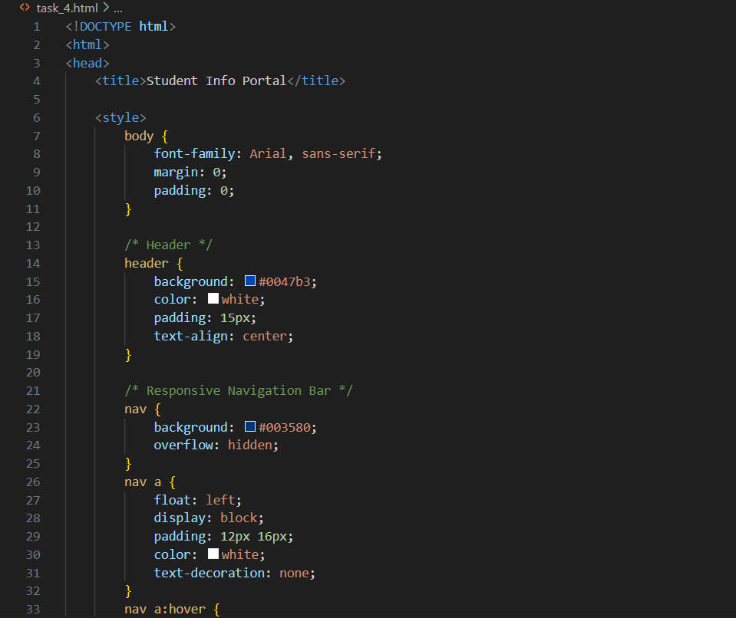  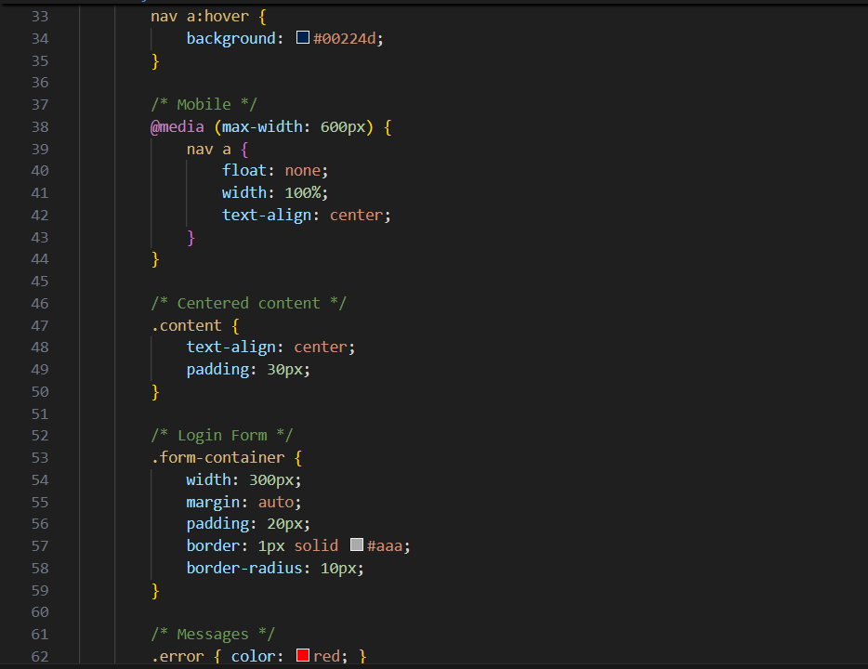  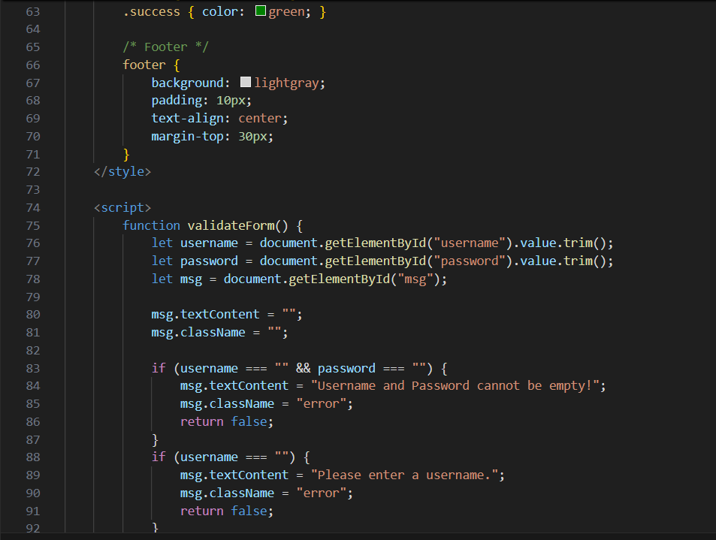  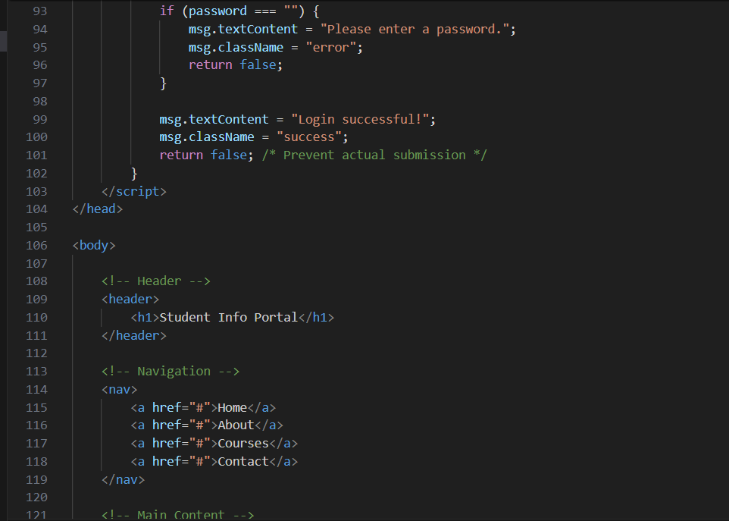  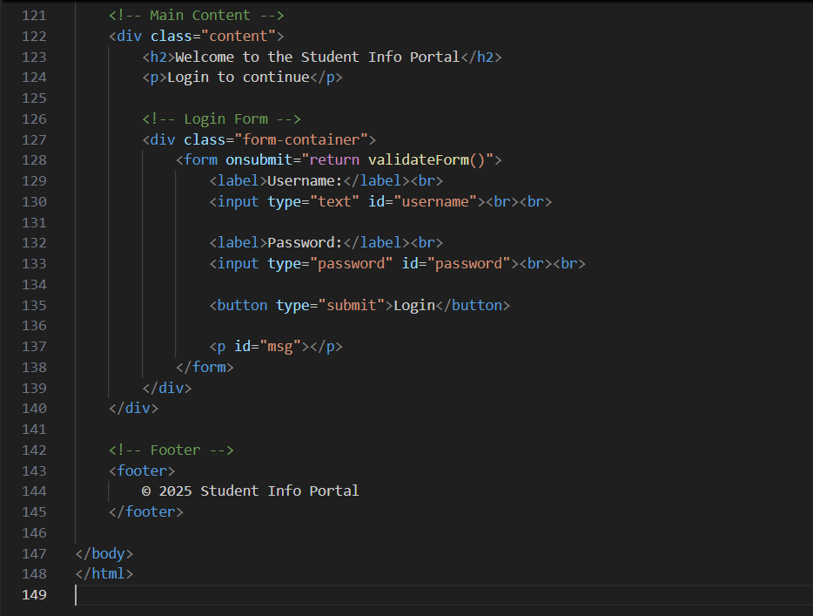  Output:   |  |  |  |  |  | Week5 - Tuesday

